

**LICENSING AUTHORITY: MAIDSTONE BOROUGH COUNCIL**

**LICENSING ACT 2003**

**LICENSING ACT 2003 (HEARINGS) REGULATIONS 2005**

**NOTICE OF DETERMINATION**

Application Ref No: 25/02407/LACPC

Applicant: Linton Park Cricket Club Rumwood Cricket Ground

Regarding Linton Park Cricket Club Rumwood Cricket Ground, White Horse Lane, Otham, Maidstone ME15 8RG

Date(s) of hearing: 27 August 2025

Date of determination: 27 August 2025

Committee Members: Councillor M Naghi

Councillor Trzebinski  
Councillor Wales

Legal Advisor in attendance at hearing(s): Robin Harris, Deputy Head of Legal Partnership, MKLS

Democratic Services Officer in attendance at hearing: Cassie Beckley

Senior Licensing Officer for application: Lorraine Neale

This was an application for **Grant** of a **Club Premises Certificate** pursuant to Part 4 Licensing Act 2003.

**A: Representations, evidence and submissions:**

The Committee considered the representations, evidence and submissions of the following parties:

1. **Applicant**

Nigel Thirkell, Club Secretary

1. **Responsible Authorities**

No representations had been made to the application by Responsible Authorities.

**Interested Parties in Attendance**

Teresa Irving, Clerk to Otham Parish Council

Alan Chard

1. **Representations considered in the absence of a party to the hearing:**

Those contained within the Report preprepared for the Licensing Sub Committee

**Consideration of the Licensing Act 2003, the Guidance under s. 182 of the Act and the Statement of Licensing Policy of Maidstone Borough Council**

The Committee has taken into account the Licensing Act 2003 and the associated Regulations.

The Committee has taken into account the Guidance under section 182 of the Act:

The Committee has taken into account its Statement of Licensing Policy.

**Determination:**

1. **The Committee has decided to:**

Grant the application subject to a condition that ‘events’ being non cricket activities will only take place on Friday or Saturday evenings. (The sub-committee reminded all those present of the right to review a licence, in the event of any breaches of the licensing objectives.)

1. **Reasons for determination:**

**Prevention of Crime and Disorder**

The Senior Licensing Officer confirmed that there had been no representation from the Police regarding this licensing objective. The sub-committee were satisfied that the measures identified in the operating schedule were sufficient to meet this licensing objective.

**Public Safety**

The sub-committee were satisfied that the measures identified in the operating schedule were sufficient to meet this licensing objective.

**Prevention of Public Nuisance**

The sub-committee had regard to all the written submissions and the further oral submissions made at the hearing with regard to this licensing objective. In particular, the applicant set out that the predominant use of the clubhouse would be ancillary to its primary use as a venue for cricket and to support matches and some socialising around games, on match days. It was suggested as a condition that events that were not ancillary to cricket might be limited to Friday and Saturdays. The applicant was happy to accept this condition. It was further suggested that the hours should be limited to 10.00 PM as there was a perception that later hours may lead to a nuisance. However, the applicant was not happy to accept this, as games may finish as late as 9.00 PM during the high summer months. The sub-committee determined that there was no evidence at the present time that the hours proposed would cause a nuisance and therefore could not justify limiting the hours at the present time. However, the sub-committee felt that the proposed and accepted condition to limit non-cricket ‘events’ to Fridays and Saturdays was a necessary and appropriate condition to prevent public nuisance and added this as a condition to the licence.

**Protection of Children from Harm**

The sub-committee were satisfied that the measures identified in the operating schedule were sufficient to meet this licensing objective.

**D: Appeal**

Entitlements to appeal for parties aggrieved by the decisions of the Licensing Authority are set out in Schedule 5 to the Licensing Act 2003. An appeal has to be commenced by the giving of a notice of appeal to the Magistrates’ Court within a period of 21 days beginning on the day on which the appellant was notified by the licensing authority of the decision to be appealed against. Parties should be aware that the Magistrates’ Court may make an Order as to costs in any Appeal.

1. **Signed: Date: 27th August 2025**
2. 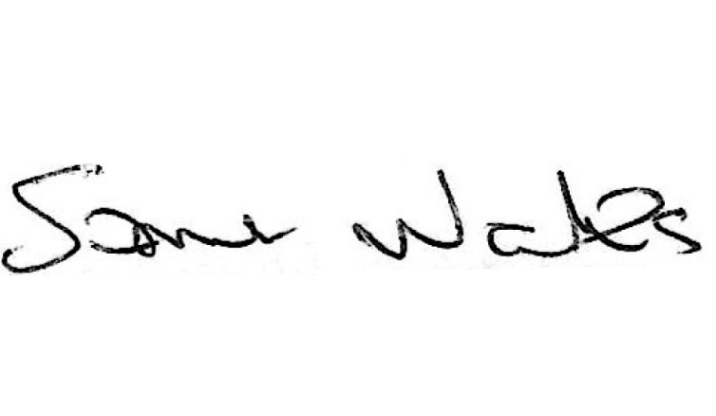
3. **Councillor Simon Wales**
4. **Chairman of the Licensing Sub Committee**
5. **A copy of the original document is held on file**